# WORD COUNTER

### A MINI PROJECT REPORT

#### Submitted by

#### Group No: G-16

**Suhana Kaura 2210992414**

**Sujal 2210992415**

**Sukhpreet Singh 2210992416**

**Sukriti 2210992417**

#### in partial fulfillment for the award of the degree of

## BACHELEOR OF ENGINEERING

***in***

COMPUTER SCIENCE & ENGINEERING



**CHITKARA UNIVERSITY**

**CHANDIGARH-PATIALA NATIONAL HIGHWAY**

**RAJPURA (PATIALA) PUNJAB-140401 (INDIA)**

##### MAY 2023

**TABLE OF CONTENTS**

|  |  |  |
| --- | --- | --- |
| **S.NO.** | **CONTENTS** | **PAGE NO.** |
| 1. | INTRODUCTION | 3 |
| 2. | PROBLEM STATEMENT | 4 |
| 3. | TECHNICAL DETAILS | 5 |
| 4. | KEY FEATURES | 6 |
| 5. | PROJECT ADVANTAGES | 7 |
| 6. | RESULTS | 8-9 |
| 7. | CONCLUSION AND FUTURE SCOPE | 10 |

**INTRODUCTION**

* This project is about a word counter website that helps the user to count the number of words and characters in a particular paragraph.
* **WORD COUNTER**

A word counter application facilitates its user to get information about the number of words

in particular article. This application is extensively used in the field of the content department.

The writer has to be sure about the number of words they are inputting in the article.

A word counter application can be made using languages such as HTML, CSS, and Javascript.

* **GOAL**

It basically helps to improve the word choice and writing style. It detects grammar mistakes

very easily.

**PROBLEM STATEMENT**

* The problem that the word counter aims to solve is the need for an accurate and efficient way

to count the number of words in a given piece of text. This need arises in various contexts , such as writing, editing, publishing and academic research.

* **FOR EXAMPLE**

Many publishers and websites have minimum and maximum word count requirements for

articles and blog posts. Word count can be useful for identifying areas where the content

may need to be expanded or condensed. It can also help ensure that the length of different

sections of a document is consistent.

* There has been some research on the impact of word count on the readability and effectiveness

of written content.

* Overall , the word counter website aims to provide a simple and reliable tool for accurately

counting the number of words in a given piece of text , helping users to meet their specific

word count requirements and achieve their writing , editing and publishing goals.

**TECHNICAL DETAILS**

* **HTML AND CSS**

These are the foundational technologies for building web pages and creating Interactive user interfaces.

HTML is basically used to create the structure of a webpage.

CSS is used to style and format the web page.

* **BOOTSTRAP**

Bootstrap code has been used in html source code. It is a free open source

front-end development framework for creation of websites . It helps to build a fully responsive

websites.

* **FONT AWESOME**

This is the Internets icon library and toolkit , used because flexibility of

styling is available.

* **GOOGLE FONTS**

Google fonts are used. They provide fonts other than standard HTML

fonts. They increase the readability , design and accessibility of the web page.

* **ANIMATION**

Animations have been made to use in the website in order to beautify its

content.

* **MEDIA QUERY**

We’ve used media query for making our website responsive.

* **IDE**

We’ve used vs code editor for writing our code.

**KEY FEATURES**

* To effectively solve the word counter problem, a word counter website has the

following key features :-

1. **Accurate word counting**

The website is able to accurately count the number of

words in a given piece of text, without including extraneous characters or missing any words.

1. **User-friendly interface**

The website has a simple and easy-to-use interface that

allows users to input their text and receive the word count results quickly and easily .

1. **Compatibility with different file formats**

The website should be able to process text in

various file formats, such as Microsoft Word documents, PDFs, or plain text files .

1. **Speed**

The website quickly processes and returnes the word count results,

without excessive loading times or delays.

* This helps us to make short and precise captions for social media.
* By providing these key features, a word counter website can effectively solve the word counter

problem and provide a useful tool for writers, editors, publishers.

**PROJECT ADVANTAGES**

### Convenient and easy to use:

### All you need to do is copy and paste your text into the word counter, and it will Automatically count the words for you. There is no software to install or download, and you can use it on any device, including a desktop computer, laptop, tablet, or smartphone.

### Fast and accurate.

The counting process happens instantly, so you don’t have to wait long for results. And because the tool uses algorithms to count words correctly, you can be sure that your counts are accurate.

### Accessible from anywhere.

As long as you have an internet connection, you can access your word count from any device, regardless of location. This makes it a convenient tool for writers who are constantly on the go.

### Accessed by various social media networking sites.

There is a word limit set up for some sites like twitter, Instagram, facebook,etc.

This website will decrement the word count automatically for such websites as soon we start

writing the article , such that we get to know where to end the text.

**RESULTS**

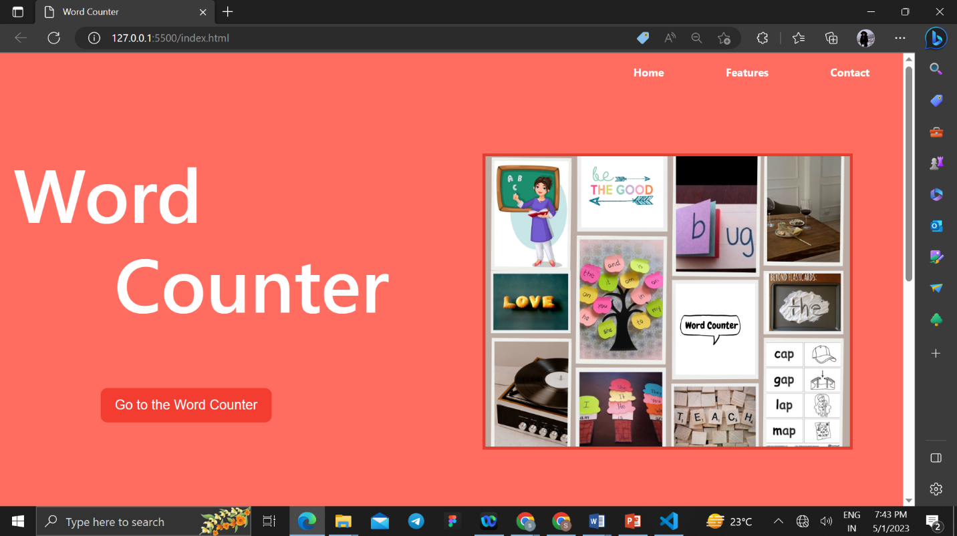

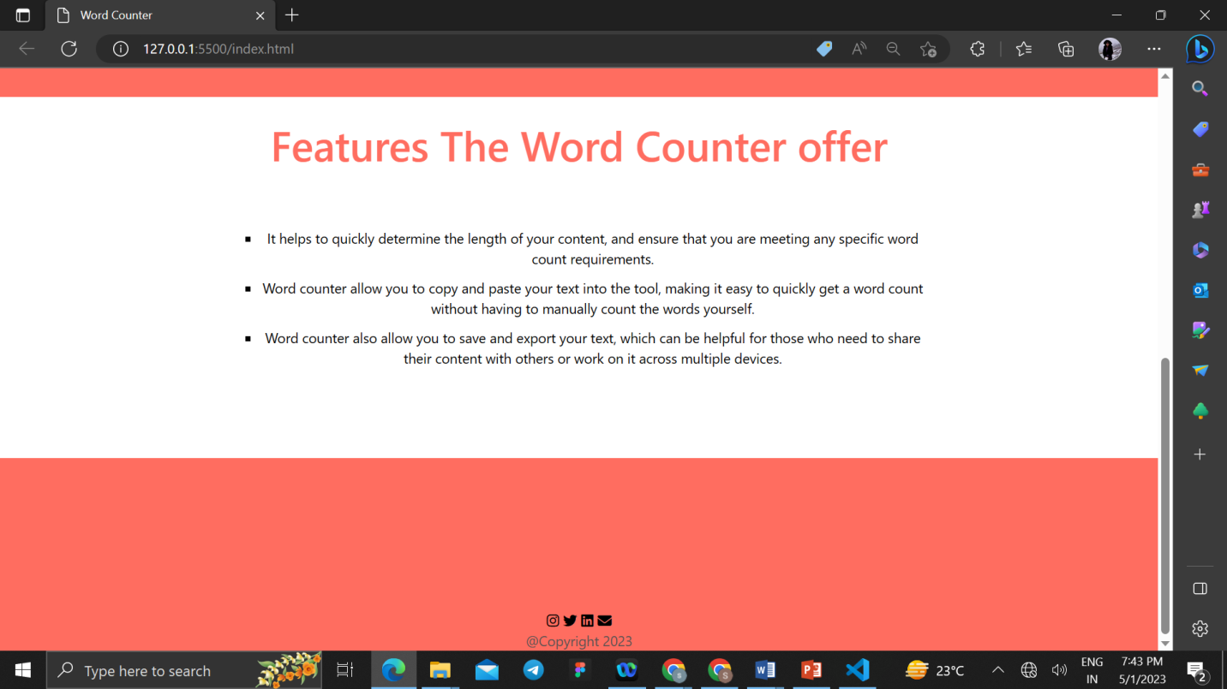

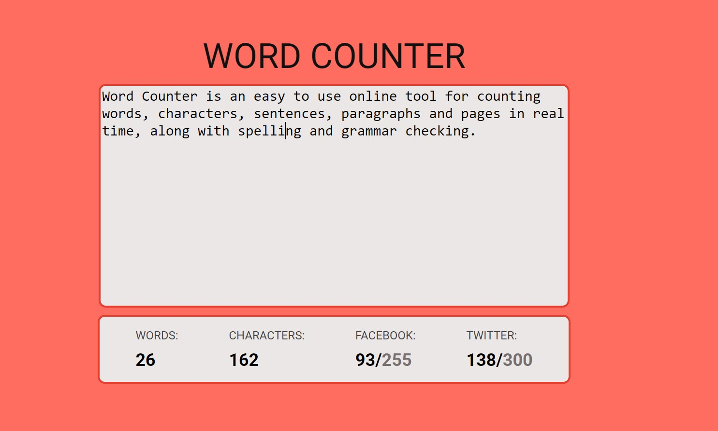

**CONCLUSION AND FUTURE SCOPE**

* **CONCLUSION:**
* Word counter is very useful website as it helps the user to determine the length of the content and ensures the word limit.
* It counts the word limit and saves the time of user.
* It also allows to save and export the text which can be very useful for those who want to share their contents with others .
* **FUTURE SCOPE:**

**1.Accessible by various social media networking sites.**

There is a word limit set up for some sites like twitter, Instagram, facebook,etc.

This website will decrement the word count automatically for such websites as soon we start

writing the article . This feature will be added with the use of javascript.

**2.Spell Check**

It’s a wonderful tool for correcting the spelling mistakes or grammatical errors.